Milestone 3 Final Report
Reservation Support Chat Platform
Evaluation Refinement and Handoff

1. Executive Summary
This report documents the Milestone 3 deliverables for the Reservation Support Chat Platform built for Vacations For You. The platform is a Phase 1 proof-of-concept designed to reduce call-center volume by giving guests an AI-powered chat interface for questions about their existing reservations.
The system is built using Spring Boot 4 with Spring AI and combines three techniques: Retrieval-Augmented Generation over VFU policy PDF documents stored in a PgVector database, tool calling to fetch live reservation and property data from the StreamX API, and an LLM-as-Judge confidence layer that escalates low-confidence responses to a human agent.
Milestone 3 covers accuracy and coverage evaluation, call-deflection potential analysis, UX refinement based on testing, and the final GitHub repository, report, and presentation. The accompanying Test Document contains 36 test cases executed to validate system behaviour. All 36 test cases passed giving a 100 percent pass rate. Findings from that execution are summarized in Section 4 of this report.

2. System Overview
2.1 Architecture Summary
The platform has five layers. The API layer is a Spring Boot ChatController with a rate limiter set to 30 requests per minute. The orchestration layer assembles session context from PostgreSQL, attaches a JDBC-backed conversation memory advisor limited to 8 messages per session, and routes each message to the right tool. The tool layer contains Spring AI @Tool methods. The infrastructure layer connects to PostgreSQL with pgvector, the StreamX API, OpenAI (gpt-4o-mini), and Geoapify. PostgreSQL handles vector search for RAG, session caching, chat memory, and analytics from a single database instance.
All tool calls run sequentially because of data dependencies. The reservation tool runs first to get the reservationId. The property tool then uses the propertyId from that response. The nearby places tool uses the latitude and longitude from the property tool. This chain cannot run in parallel.

Architecture Diagram
The diagram below illustrates how the major components interact at runtime.
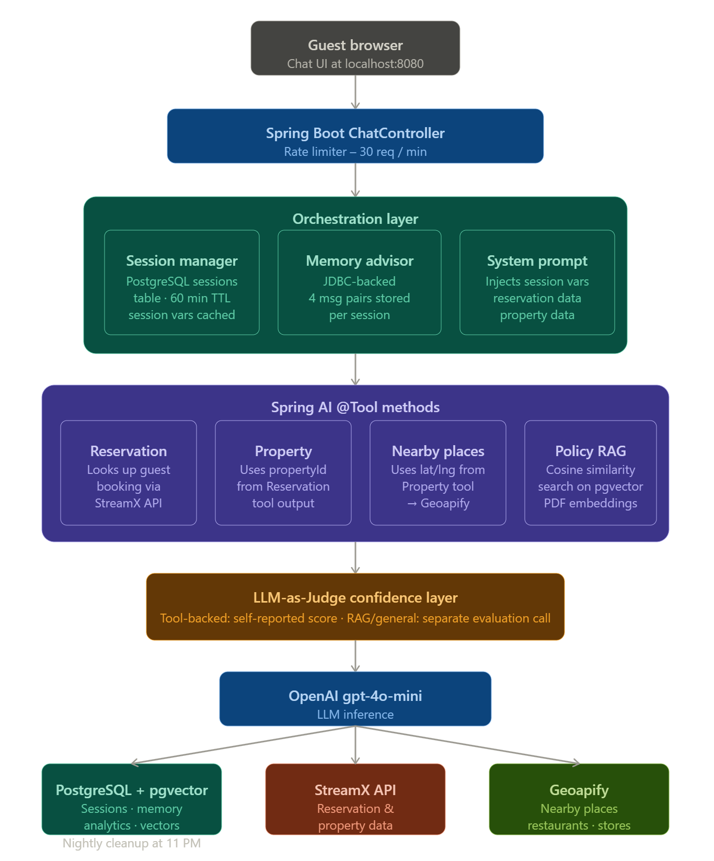

2.2 Database Tables
The system uses a single PostgreSQL instance with pgvector for all data storage. The tables used are described below.
The sessions table stores the session identifier, the verified flag, and cached reservation and property data. Cache entries have a 60-minute TTL. This prevents repeated StreamX API calls within the same session and speeds up responses after the first lookup. Session variables such as reservationId and propertyId are also stored here so the system prompt can inject them directly into each request.

The spring_ai_chat_memory table stores the conversation history for each session. The memory advisor keeps the 4 most recent message pairs (8 messages total) in this table. Older messages are dropped to keep the context window manageable. This is a Table managed by Spring, so we cannot make any changes to this table.

The vector_store table (managed by pgvector) stores the embedded chunks of the VFU policy PDF documents. The PolicyRagTool performs a cosine similarity search against this table for every policy or FAQ question.

The chat_analytics table stores one row per request. Each row captures the session ID, the question category, the tool called, the confidence score, and the response time. Grafana reads this table to power the analytics dashboard. This table acts like a history table to check the conversations. The data older than 7days would be cleaned up via Batch Job.

2.3 Batch Cleanup Jobs
Three scheduled batch jobs run nightly at 11 PM to clean up stale data. The SpringAiChatMemoryCleanupScheduler and ExpiredSessionCleanupScheduler deletes rows from the spring_ai_chat_memory table and sessions table respectively where the timestamp is older than 1 day. The ChatAnalyticsCleanupScheduler deletes rows from the chat_analytics table where created_at is older than 7 days.

If VFU wants to retain conversation history or analytics data for a longer period they can change the retention duration in the scheduler configuration. For example, setting the threshold to 30 days instead of 7 days means the system keeps the last 30 days of chat memory and analytics. The trade-off is more storage consumption in the database.

Note: Companies usually store anywhere between 1-3 months of data in the logs.

Test case TC-36 in the accompanying test document confirmed that the batch jobs ran successfully on 2026-04-16 at 11 PM and removed the expected number of rows from both tables.

2.4 Tool Class and System Prompt
The Tools class contains all Spring AI @Tool annotated methods. Each method has a description string that Spring AI reads to decide which tool to call based on the end-user message. The current tools are the reservation lookup tool, the property details tool, the nearby places tool, and the policy RAG tool.

If VFU wants to add new capabilities such as booking new reservations, processing sales, handling payment queries, or logging maintenance requests, the development team needs to add a corresponding method to the Tools class with a clear description. Spring AI reads those descriptions at runtime and will call the new method automatically when the guest message matches the description.

Any addition or removal of a tool also requires a corresponding update to the system prompt. The system prompt tells the LLM what tools are available and how to use them. If a tool is added without updating the system prompt the LLM may not use it correctly. If a tool is removed without updating the system prompt the LLM may attempt to call a tool that no longer exists.

The system prompt currently injects session variables, reservation data, and property data directly into the prompt. This was a deliberate fix to reduce hallucination. When the LLM has the exact reservation and property data in its context it does not need to guess or fabricate values.

For example, to support new bookings or sales transactions the team would add a createReservationTool method to the Tools class, update the system prompt to tell the LLM it can create reservations, and connect the method to the StreamX API endpoint for reservation creation. Payment processing would follow the same pattern. A processPaymentTool method would call the StreamX payment endpoint and the system prompt would be updated to describe when the LLM should trigger a payment. Maintenance request handling would work similarly through a submitMaintenanceRequestTool method.

2.5 Key Technical Decisions
PostgreSQL with pgvector was chosen as the sole data store to avoid a separate vector database which keeps the infrastructure simpler without sacrificing functionality.
Reservation and property API responses are cached in the sessions table with a 60-minute TTL. This prevents repeated StreamX calls within the same session and speeds up responses after the first lookup.

Reservation and Property Tool data is verified by LLM-as-Judge when the context is provided to it. Hence it gives a much better confidence scoring. LLM-as-Judge acts as a safety net that stops any hallucinated incorrect responses from reaching the end user. If the confidence is less for any response, then we return a generic response to the user saying the Chatbot can only help with Reservation, Property, Policy and nearby places suggestions. Anything else needs to be reached out to Customer support.

2.6 Data Flow
A guest opens the chat UI. Policy or FAQ questions asked without logging in go directly to the RAG tool using a similarity search over the embedded PDF documents. The response is evaluated by the LLM-as-Judge before being returned.

For reservation-specific questions the guest provides their 6-digit reservation ID and last name. The reservation tool calls the StreamX API and verifies the last name matches. If it does the session is marked as verified and reservation data is cached. All follow-up questions in the same session use that cached data.

Even if the memory window slides, the chatbot doesn’t ask for the reservation ID and lastname because we are already storing the session variables and reservation/property facts. The chatbot makes use of them and answers the user’s question.

3. UX Refinements Based on Testing
3.1 Three Conversation Paths
Testing confirmed the three conversation paths work as designed. The policy path answers FAQ and policy questions immediately without any login by routing through the RAG tool. The verified session path gives property-specific and reservation-specific answers after the guest confirms their reservation ID and last name. The unverified session path prompts for credentials when reservation-specific questions are asked before verification.
A guest asking about the cancellation policy before logging in gets an immediate answer from the policy documents. That same guest asking about the security deposit on their specific property after logging in gets the property-specific figure from the StreamX API.

3.2 Response Presentation
Each bot response shows a confidence badge and a source tag alongside the answer. Source tags are POLICY RAG, RESERVATION, PROPERTY, and GEOAPIFY_PLACES. This makes it clear to the guest and the reviewer where each answer came from.
Rate-limit errors show inline in the chat as HTTP 429 messages rather than crashing the session.

3.3 Out-of-Scope Handling
Off-topic questions get a polite message explaining the chatbot can only help with reservation, property, and nearby places questions along with the VFU support phone number. Booking modification, payment, and maintenance requests fall into this path since Phase 1 is read-only.

3.4 Improvements Noted for Phase 2
The rate-limit error is currently a raw HTTP 429 response. It should become a friendly chat-bubble message telling the guest to try again in a moment.
The confidence badge is small and hard to read. A color-coded indicator such as green for high confidence, yellow for medium, and red for escalation would help.
Escalation currently gives a phone number. A future phase should hand off to a live agent with the session context already transferred.
If the user is inactive for a long time, the chatbot needs to show a warning timer and close the chat after that.

4. Accuracy and Coverage Evaluation
4.1 Test Execution Summary
Testing used 36 test cases documented in the accompanying Test Document (SWE7903-Spring2026-Team1-TD02). Test cases involving reservation and property data required IP-whitelisted access to the StreamX API. Testing was done locally since the KSU server IP was not yet whitelisted. All 36 test cases passed with a 100 percent pass rate exceeding the 80 percent POC sign-off threshold.

4.2 Results by Category
Authentication and Session Verification (TC-01 to TC-06): All 6 test cases passed. Reservation lookup with a valid confirmationId and last name worked correctly. Wrong last name and non-existent reservation IDs both returned the expected denial message. Session persistence across follow-up questions worked without re-prompting for credentials.
Policy and RAG Responses (TC-07 to TC-10 and TC-13): All 5 test cases passed. Cancellation policy, pet policy, and security deposit queries returned accurate answers from the policy documents with POLICY_RAG source tags and confidence scores between 85 and 100 percent. Check-in time before login returned the general policy times correctly.
Reservation and Property Info (TC-11 to TC-12 and TC-14 to TC-21): All 10 test cases passed. The system correctly prioritized property-specific and reservation-specific data over generic RAG answers when the session was verified. For example TC-12 showed that the property had a no-pets policy while the RAG document would say 2 pets are allowed. The tool correctly returned the property-specific restriction.
Nearby Places (TC-22 to TC-24): All 3 test cases passed. Geoapify returned relevant restaurants, grocery stores, and attractions near the property with GEOAPIFY_PLACES source tags and 100 percent confidence.
Escalation and Out-of-Scope (TC-25 to TC-27): All 3 test cases passed. Off-topic questions about weather, booking modifications, and unknown policy topics all received the expected boundary message with the VFU support contact details.
Rate Limiting and UI (TC-28 to TC-31): All 4 test cases passed. The rate limiter triggered correctly at the message threshold. Session management worked correctly with separate sessions per browser tab, chat memory persisted after page refresh, and the New Chat button cleared the session as expected.
Advanced Policy Tests (TC-32 to TC-35): All 4 test cases passed. The chatbot correctly refused to classify lions and tigers as pets under the pet policy even when the user tried to trick it. It correctly performed the pet fee calculation and applied the weight and type restrictions simultaneously.
Batch Job (TC-36): The nightly cleanup job ran at 11 PM and removed 170 rows from the chat memory table and 2 rows from the analytics table confirming that automated cleanup works.

4.3 Overall Pass Rate
Total Test Cases | 36
Passed | 36
Failed | 0
Blocked | 0
Pass Rate | 100%
POC Sign-Off Threshold (above 80%) | Met

The 80 percent threshold for POC sign-off was met. Client sign-off is expected after the Milestone 3 presentation on April 29, 2026.

5. Call-Deflection Potential Analysis
5.1 Approach
Deflection potential is assessed by matching the question categories the chatbot covers against the types of calls VFU receives. A category is a strong deflection candidate if the chatbot passed 80 percent or more of its related test cases.

5.2 Coverage and Deflection by Category
Question Category | Example Questions Handled | Test Pass Rate | Deflection Candidate
Check-In and Check-Out | What time is check-in? How do I get the keys? What is the check-out procedure? | 100% | Yes
Property Location and Access | What is the address? Is there parking? | 100% | Yes
Amenities and Features | Is there Wi-Fi? Are linens provided? What is the max occupancy? | 100% | Yes
House Rules and Policies | Are pets allowed? What is the cancellation policy? What is the security deposit? | 100% | Yes
Local Information | What restaurants are nearby? Where is the nearest grocery store? | 100% | Yes
General Reservation Details | What are my check-in dates? Can you confirm my reservation? How much do I owe? | 100% | Yes

5.3 Estimated Impact
Policy and FAQ questions are the strongest deflection candidates because they need no identity verification and are answered directly from the policy documents. Guests do not need to wait for an agent to look up information that already exists in those files.
Property-specific questions like parking, amenities, and security deposit represent meaningful volume once a guest is verified. Booking modifications, refunds, and maintenance requests remain out of scope for Phase 1 and will continue to need human handling.

5.4 Cost of Running the Chatbot
We do not have access to VFU internal data on call-center agent billing or pay rates so we cannot directly compare agent cost to chatbot cost. However, we can estimate the cost of running the chatbot based on token usage.
The system prompt for each request is large because it includes session variables, cached reservation data, cached property data, and tool descriptions. The system prompt alone is approximately 2000 to 2500 tokens per request. Each user message adds roughly 20 to 50 tokens. The LLM response is typically 100 to 300 tokens. The LLM-as-Judge runs a second call for RAG responses which adds another 500 to 800 tokens. For reservation and property tool calls the tool responses add another 300 to 500 tokens to the context.
The model in use is gpt-4o-mini which is priced at $0.15 per million input tokens and $0.60 per million output tokens as of April 2026. For a single user message with a full tool chain the total token count is roughly 3500 to 4000 input tokens and 200 to 400 output tokens. That works out to approximately $0.0005 to $0.0008 per single exchange.
If a user chat session involves 10 back-and-forth messages the total cost for that session is roughly $0.05 to $0.08. Rounding to a practical estimate a single user session of about 10 messages costs somewhere around $0.01 or less.
If VFU currently receives about 100 customer calls per day and even half of those could be redirected to the chatbot that would be 50 chatbot sessions per day. At $0.01 per session the daily chatbot inference cost would be approximately $0.50. If the full 100 calls were redirected the daily cost would be approximately $1.00. On a monthly basis that comes to roughly $15 to $30 per month just for LLM inference at the current call volume.
Note: These are approximations. Actual costs depend on how long each conversation runs, how many tool calls are triggered per message, and whether the LLM-as-Judge is invoked. Sessions involving only policy RAG questions will be cheaper than sessions that chain all three tools together. Actual unique customer count and average chat length could be higher or lower depending on seasonal patterns.

5.5 Deployment Costs
The chatbot requires a runtime environment for the Spring Boot application, a PostgreSQL instance with pgvector, and an optional monitoring stack with Prometheus and Grafana. Several deployment options are available with different cost profiles.
Option 1: Railway
Railway is a managed platform that supports Docker-based deployments. The project was previously tested and verified to run on Railway. For a Spring Boot service, a PostgreSQL instance with the pgvector extension, and basic monitoring the estimated monthly cost on Railway is between $10 and $25 per month depending on memory allocation and request volume. Railway charges based on resource usage rather than a flat fee so light usage stays cheap.
Option 2: AWS (Amazon Web Services)
AWS offers several options for running a Spring Boot application. The simplest is an EC2 t3.small or t3.medium instance running the Spring Boot JAR directly or via Docker. A t3.small instance costs roughly $15 per month. PostgreSQL can be run on the same instance or on Amazon RDS. An RDS db.t3.micro instance with PostgreSQL costs roughly $15 to $25 per month. Total AWS infrastructure cost would be approximately $30 to $50 per month before data transfer fees. The pgvector extension is supported on RDS PostgreSQL from version 15 onward.
Option 3: In-House Server (Our Recommendation because of IP Whitelisting)
If VFU has existing server infrastructure they can host the application on-premises. The server needs Docker installed to run the Docker Compose stack. Docker installation on Ubuntu is straightforward using the official apt repository. The ongoing cost for an in-house server is primarily electricity and existing IT staff time for maintenance. There is no recurring cloud bill for the compute itself though VFU would still pay for the OpenAI and Geoapify API calls based on usage. If the server already exists the incremental monthly cost for running the chatbot on it is close to zero beyond the API call costs.

Summary of Estimated Monthly Costs
Deployment Option | Infrastructure Cost / Month | LLM Inference / Month | Approximate Total / Month
Railway | $10 to $25 | $15 to $30 | $25 to $55
AWS (EC2 + RDS) | $30 to $50 | $15 to $30 | $45 to $80
In-House Server | Near zero (existing infra) | $15 to $30 | $15 to $30

Note: These numbers are approximations based on current pricing as of April 2026. Actual costs depend on traffic volume, session length, and provider pricing changes. The LLM inference cost column assumes 100 chatbot sessions per day at the per-session cost described in Section 5.4.

Important note on StreamX IP Whitelisting: StreamX restricts API access by IP address. If VFU deploys the chatbot on a cloud provider such as Railway or AWS the deployment will receive a new public IP address each time the service restarts or is redeployed. Every new IP address would need to be whitelisted with StreamX before the chatbot can call the reservation and property APIs. This creates an ongoing operational burden. To avoid this VFU should purchase a static IP or NAT gateway service from the cloud provider so the outbound IP stays fixed across deployments. On AWS this is done through an Elastic IP attached to a NAT gateway. On Railway this requires a static IP add-on. The cost for a static IP or NAT gateway is typically $5 to $20 per month depending on the provider. Without a fixed IP every deployment requires a StreamX whitelist update which could cause downtime for guests.

6. GitHub Repository
https://github.com/johnpranoy7/RagToolAgentChatbot

6.1 Repository Contents
The repository contains source code for the Spring Boot 4 application including all service classes, tool definitions, configuration, and database migration scripts. It also includes a README with Docker Compose startup instructions and environment variable configuration, architecture diagrams from the design document, UI wireframes from Milestone 1, the Test Document and this Milestone 3 report, and the final presentation slides.

6.2 Running the Application
Docker Compose starts PostgreSQL with pgvector, the Spring Boot application, Prometheus, and Grafana. Three environment variables must be set before startup: OPENAI_API_KEY for gpt-4o-mini, StreamX API credentials for reservation and property lookups, and the Geoapify API key for nearby places queries. The chat UI is at http://localhost:8080/ and the analytics dashboard is at http://localhost:8080/api/dashboard.
If deploying to an in-house server Docker must first be installed on that server. On Ubuntu the installation uses the official Docker apt repository. After installation Docker Compose can be run with the same compose file used for local development. No application code changes are needed between local and server deployments except pointing in application.properties from env dev to prod.

7. Evaluation Metrics
Metric | Target | Actual
End-to-end response time | Under 10 seconds | 7 to 8 seconds average (Grafana dashboard confirmed)
Policy query correct response rate | Over 80% | 100% (all policy test cases passed)
Rate limiting | HTTP 429 at 30 req/min | Triggered correctly at threshold
Out-of-scope handling | Polite message with VFU phone number | Passed on all escalation test cases
Intent routing accuracy | Correct tool called for each question type | Correct tool used across all 36 test cases
Confidence escalation | Low-confidence responses escalate to human agent | Escalation triggered correctly with RULE_FALLBACK tag
Overall test pass rate | Above 80% | 100% (36 of 36 passed)

The 7 to 8 second response time is higher than ideal but within the under-10-second target. The main driver is the large system prompt of over 2000 tokens which OpenAI takes 3 to 4 seconds to process. The sequential tool chain for reservation, property, and nearby places queries adds additional latency on top of that. Attempts to reduce the prompt size during development caused regressions in other test scenarios so the current prompt size was kept as a deliberate trade-off.

Conclusion
The Reservation Support Chat Platform Phase 1 POC delivers a working AI-powered guest support interface that covers the post-booking questions VFU call-center staff handle most often. The system chains tool calls correctly to pull reservation and property data from StreamX, searches policy documents using RAG, finds nearby places through Geoapify, and escalates low-confidence responses automatically.
Testing across 36 scenarios confirmed that all three conversation paths work as designed and that the system handles invalid inputs, unverified session requests, out-of-scope questions, and rate-limit conditions without failing. The 100 percent pass rate exceeds the 80 percent POC sign-off threshold.
The tool-calling pattern makes it straightforward to add new capabilities in Phase 2 by registering additional @Tool methods and updating the system prompt. PostgreSQL as the sole data store and the Docker Compose setup keep the infrastructure simple and reproducible. The estimated monthly operating cost ranging from $25 to $80 depending on deployment option is low relative to the call-center volume it can deflect.

